TavrendoPass

User Guide
Version 1.1

Know your delivery is ready before you send it.
A practical guide to checking folders, reusing Profiles, verifying after a copy, comparing live folders or Saved Records, and saving clear results.
Who this guide is for
Anyone using TavrendoPass to prepare, verify, compare, or document file-folder deliveries on Windows.

Table of Contents
# | Topic | Page
1 | Start Here: What TavrendoPass Does | 3
2 | Quick Start: Your First Folder Check | 4
3 | Choose What You Want to Do | 5
4 | Core Concepts and Terms | 6
5 | Check Folder | 7
6 | Profiles and Starter Templates | 9
7 | Create or Customize a Profile | 10
8 | Understanding PASS, WARN, and FAIL | 11
9 | Save Reports and Records | 12
10 | Verify Folder | 13
11 | Compare Versions and Live Folders | 15
11a | Compare Two Live Folders | 16
11b | Comparison Results and CSV | 17
12 | Common Workflows | 18
13 | Troubleshooting | 19
14 | Frequently Asked Questions | 20
15 | Safety, Privacy, and What TavrendoPass Does Not Do | 22
16 | Quick Reference | 23
17 | Getting Help | 24
Tip
Keep this guide nearby during your first few checks. Once you understand Profiles and Saved Records, the rest of TavrendoPass becomes much easier.

1. Start Here: What TavrendoPass Does
TavrendoPass is a local-first desktop application for Windows 10 and Windows 11, 64-bit. It checks file-delivery folders against reusable requirements.
It helps you catch folder problems before delivery, save a record of a folder, and verify a current folder against that record.
Version 1.1 also compares two live folders directly, restores recent check setups, and explains scan coverage and progress.
•  •  •  •  •  • | Check folders and files against reusable requirements.  Use Profiles to define the checks for a delivery.  Review PASS, WARN, or FAIL and coverage exceptions.  Save workflow-specific CSVs, verification reports, and Saved Records.  Verify a folder or copied destination against a Saved Record.  Compare saved versions or two live folders directly.
Important
TavrendoPass checks configured file and folder rules. It does not judge whether the content of a document, image, design, contract, or technical file is correct.

What TavrendoPass does not do
• It does not automatically repair a delivery.
• It does not silently move, rename, delete, or overwrite source files during an audit.
• It is not antivirus software or malware scanning.
• It is not cloud backup, file sync, or automatic document classification.
• It does not certify legal, engineering, professional, or content correctness.

Install or update TavrendoPass
Use the Windows installer supplied through your TavrendoPass purchase or official download. Follow the installer prompts, then open TavrendoPass and confirm version 1.1.0 in Help / About.
Review your Profiles and recent history after an update. Use the License screen if activation is needed; license activation and purchases are separate from local folder checking.

2. Quick Start: Your First Folder Check
If you only read one section before using TavrendoPass, use this one.
1 | Open Check Folder  Select Check Folder from the left navigation.
2 | Choose the folder you want to check  Select the delivery folder you plan to send, save, archive, or hand off.
3 | Choose a Profile  Use a Starter Template, a saved Profile, or a Profile you created yourself. The Profile defines the rules TavrendoPass will evaluate.
4 | Run the check  TavrendoPass scans the selected folder and evaluates the enabled rules.
5 | Review the result  Read PASS, WARN, or FAIL, individual issues, and coverage warnings. A completed progress bar is not a PASS result.
6 | Save results if needed  Save an audit CSV or Saved Record. See section 9 for the different uses of each output.
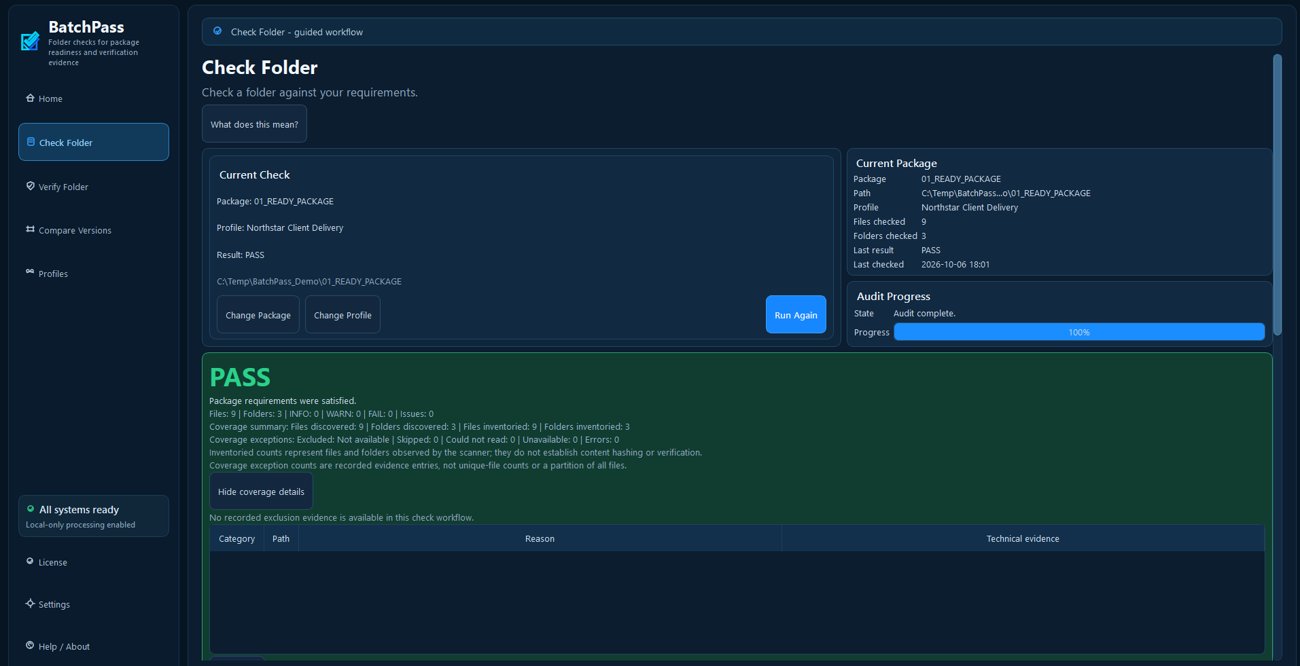
Example: Check Folder shows its result and coverage. Review the actual result separately from completed progress.

3. Choose What You Want to Do
If you want to... | Use... | What it does
Check a delivery before sending it | Check Folder | Checks the selected folder against a Profile.
Reuse the same rules again | Profiles | Stores reusable delivery requirements.
Start quickly | Starter Templates | Provides editable starting points for common delivery types.
Confirm a checked folder has not changed | Verify Folder | Compares the folder with a Saved Record using file fingerprints.
See what changed between saved versions | Compare Versions | Compares two Saved Records without scanning either live folder.
Keep proof of what was checked | CSV / verification report / Saved Record | Creates readable reports and machine-readable records.
Compare two current folders | Compare Two Live Folders | Scans Folder A and Folder B; no Profile or existing Saved Records required.
Verify a destination after copying | Verify After Copy/Delivery | Verifies the destination against an original Saved Record; TavrendoPass does not copy files.
Reuse a recent Folder and Profile | Repeat Recent Check | Restores a previous setup so you can run a fresh check.

Home shortcuts and recent checks
Home offers Check Folder, Verify Existing Folder, Verify After Copy/Delivery, Compare Saved Versions, Compare Two Live Folders, and Repeat Recent Check.
Repeat Recent Check restores the recorded Folder and Profile pair. Review the restored choices, then start the check. It does not reuse old results or run automatically. The new run reads the current folder and current Profile.
If the folder or Profile has moved or is unavailable, choose a replacement explicitly. On smaller windows, scroll vertically and horizontally to reach all Home actions and recent activity.

4. Core Concepts and Terms
Folder / Package: The folder you are checking. In some screens or older documentation, the word package may be used for the delivery folder.
Profile: A reusable set of rules that defines what TavrendoPass should check.
Starter Template: A ready-made Profile starting point that you can review and customize.
Saved Record: A saved folder inventory with file paths and SHA-256 fingerprints. It records a point in time and can support later verification or comparison.
SHA-256 fingerprint: A digital fingerprint calculated from a file's contents. If file contents change, the fingerprint changes.
Verification Report: A readable verification output. Use the report action on Verify; comparison results are exported through Save Comparison CSV.
CSV Report: A structured report that can be opened in spreadsheet tools.
Verify Folder: Checks whether a current folder still matches a Saved Record.
Compare Versions: Compares Earlier and Newer Saved Records. The same page also contains a separate live-folder comparison.
Live folder comparison: Scans two current folders directly. Folder A is the baseline; Folder B is the folder compared against it. They can be an original and a copy, or two different versions.
Coverage evidence: Information about what the workflow discovered, inventoried or hashed, and what it skipped or could not read.
Possible Rename/Move: A conservative candidate based on matching content fingerprints and size. It is not proof that a file was moved or renamed.

5. Check Folder
Use Check Folder when you are preparing a delivery and want to know whether it satisfies the selected requirements.

Typical workflow
1 | Choose the folder  Select the exact folder you plan to deliver.
2 | Choose the Profile  Pick the rules that match this type of delivery.
3 | Run the check  TavrendoPass inventories files/folders and evaluates enabled checks.
4 | Review the summary  Read PASS, WARN, or FAIL, counts, and the coverage summary. Open or scroll to the detailed issues and exception reasons.
5 | Review findings and coverage  Review issues and recorded exceptions, even when the result is PASS.
6 | Fix outside TavrendoPass  Correct the source files using your normal tools.
7 | Run Again  Re-run the check until the result reflects the final folder.

Understanding progress
During discovery, the total may be unknown and progress may be indeterminate. When a stage has a known total, TavrendoPass shows bounded progress for that stage. A new stage may use a different total.
Successful completion can show 100% even when the folder result is WARN or FAIL. Progress describes work completed; the result describes what the check found. Cancelled or failed runs do not establish a completed check.
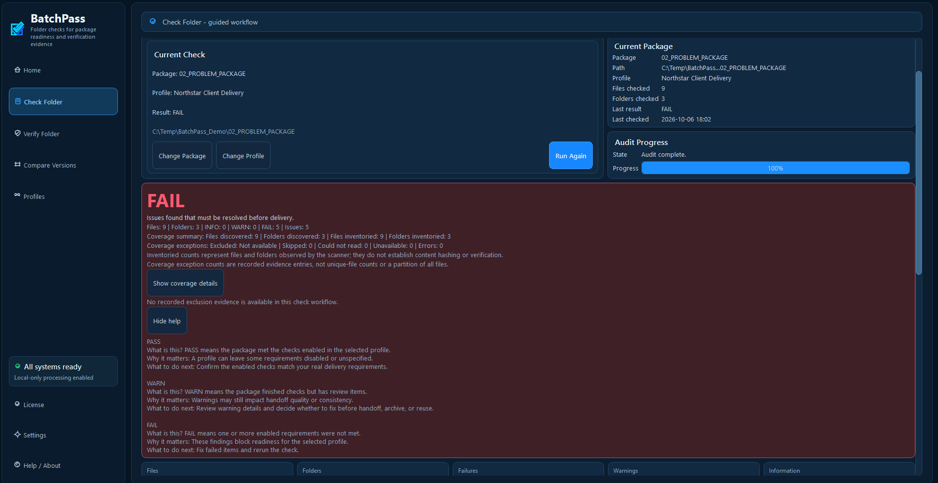
Example: a problem folder shows FAIL with issue details. Scroll to review the full issue list.
Good practice
Run TavrendoPass against the same final folder you intend to send. If you change the folder after the check, run the check again before delivery.

6. Profiles and Starter Templates
Profiles are the heart of repeatable checks. A Profile tells TavrendoPass which rules apply to a particular type of delivery.
Only enable requirements that genuinely apply to that delivery.

Bundled examples and templates
TavrendoPass includes sample Profiles and Starter Templates as starting points for common deliveries.
Examples include generic folder checks, website client handoffs, photo delivery, and numbered document sets. Review their rules before use.
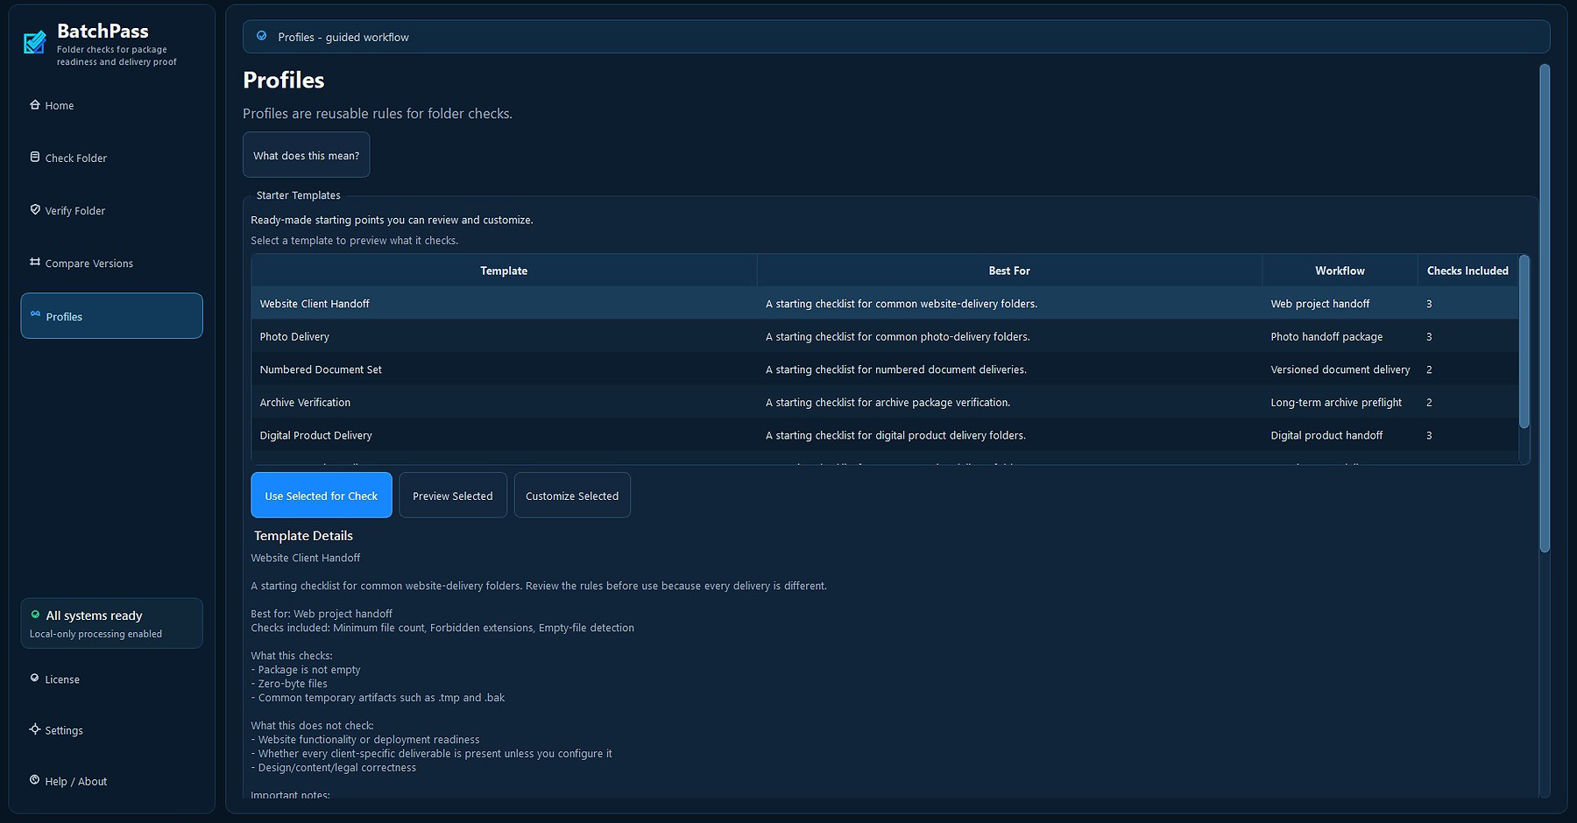
Profiles screen: review Starter Templates, saved Profiles, and available checks.

When should I use a Starter Template?
• When you are new to TavrendoPass and want a quick starting point.
• When the delivery resembles one of the included use cases.
• When you want to learn which checks are useful before building your own Profile.

When should I create or customize a Profile?
• When a client or workflow has specific required files or folders.
• When you need repeatable filename, extension, count, size, duplicate, or sequence rules.
• When you want the same delivery rules to be reused across projects.
Profile design rule
Only require what is truly required. Overly strict Profiles create noisy failures and make the check less useful.

7. Create or Customize a Profile
A custom Profile lets you turn a delivery checklist into repeatable rules.
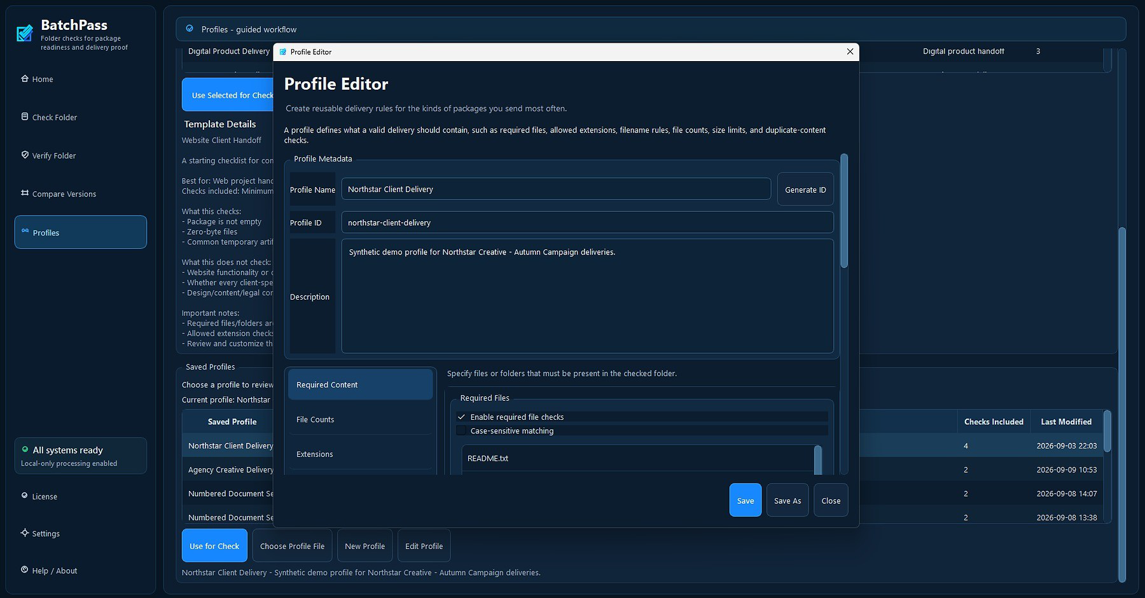
Profile Editor: create reusable rules for the types of folders you deliver most often.

A practical setup method
1 | Start from a known-good example  Use a folder that represents a correct delivery whenever possible.
2 | Name the Profile clearly  Use a name that tells you what delivery it belongs to, such as Website Client Handoff or Client ABC Final Delivery.
3 | Add required content  Specify files or folders that must always be present.
4 | Add structural checks  Configure file counts, allowed or forbidden extensions, size limits, duplicate checks, filename rules, or sequence rules as appropriate.
5 | Save the Profile  Save your rules so they can be selected from Check Folder later.
6 | Test both success and failure cases  Run the Profile against a known-good folder and against a deliberately broken example to confirm the rules behave the way you expect.

8. Understanding PASS, WARN, and FAIL
Result | Meaning | What to do
PASS | Configured checks were satisfied based on available evidence. Review coverage and exceptions. | If this is the final folder, save a report or record if you need proof.
WARN | The folder may still be usable, but one or more items deserve  review. | Read the warning details and decide whether the condition is acceptable.
FAIL | One or more required checks did not pass. | Review the issue list, correct the folder, and run the check again.

Common issue examples
Required file is missing - A Profile says a file must exist, but TavrendoPass did not find it.
Empty file detected - A zero-byte file was found where the Profile checks for empty files.
Duplicate content detected - Two files have matching content fingerprints. This identifies exact duplicate content, not visually similar photos or similar document wording.
File-size issue - A file exceeds or falls outside a configured size rule.
Sequence gap - A numbered set has a missing expected number.
Extension issue - A file extension does not match the allowed or forbidden extension rules.

Read coverage before relying on a result
Files inventoried and folders inventoried describe the scanner’s observed inventory. They do not prove that every file was hashed or verified. Verify and live Compare separately show successfully hashed files when that evidence is available.
Review excluded, skipped, could-not-read, unavailable, and error entries. Exception counts are recorded evidence entries, not unique-file counts, and do not divide all files into separate groups.
Unknown or not available means the workflow has no supported total. Missing exclusion evidence does not mean nothing was excluded. Do not treat an incomplete scan as proof of full folder coverage.
Saved-record comparison reads stored data only. It does not confirm current folder readability or current absence of a file. Live-comparison coverage totals describe Folder A and Folder B together.
Results describe the recorded observations, not a continuously monitored or locked snapshot. Avoid changing files while a check, verification, or comparison is running; rerun if the source changes.

9. Save Reports and Records
Check, Verify, and Compare offer different outputs. Choose the output for the workflow you completed; a report is not a substitute for a Saved Record.
Output | Best for | Use later?
Verification Report | Readable verification results and available coverage details | Yes - for reference
Audit CSV | Check issues in a spreadsheet; project tracking | Yes - for reference/analysis
Saved Record | Saved inventory for later Verify Folder and saved-version comparison | Yes - operationally important
Recommended for important deliveries
Save the check CSV and a Saved Record. The CSV documents findings; the Saved Record enables later verification. Save verification outputs after checking the destination.

Exports depend on the workflow
Check Folder: Save the audit CSV to document findings, and create a Saved Record when you need a baseline for later verification or saved-version comparison.
Verify Folder and Verify After Copy/Delivery offer Save Verification CSV for spreadsheet-friendly verification rows and Save Verification Report for readable verification text and coverage details. Review the page’s warnings alongside your saved outputs.
Saved-version and live-folder comparisons offer Save Comparison CSV. This CSV records file-change rows; it does not include the coverage warnings or full coverage exception evidence shown on the Compare page.
Keep the Saved Record if you will need future verification. A CSV or readable report does not replace it. Live-folder comparison does not automatically create a Saved Record.
Save reports to your chosen output location. Protect reports and records that contain private filenames or paths, and confirm the output was created before relying on it.

10. Verify Folder
Use Verify Folder when you have a Saved Record and want to check whether a current folder still matches it. To verify a copied delivery, select the destination folder.
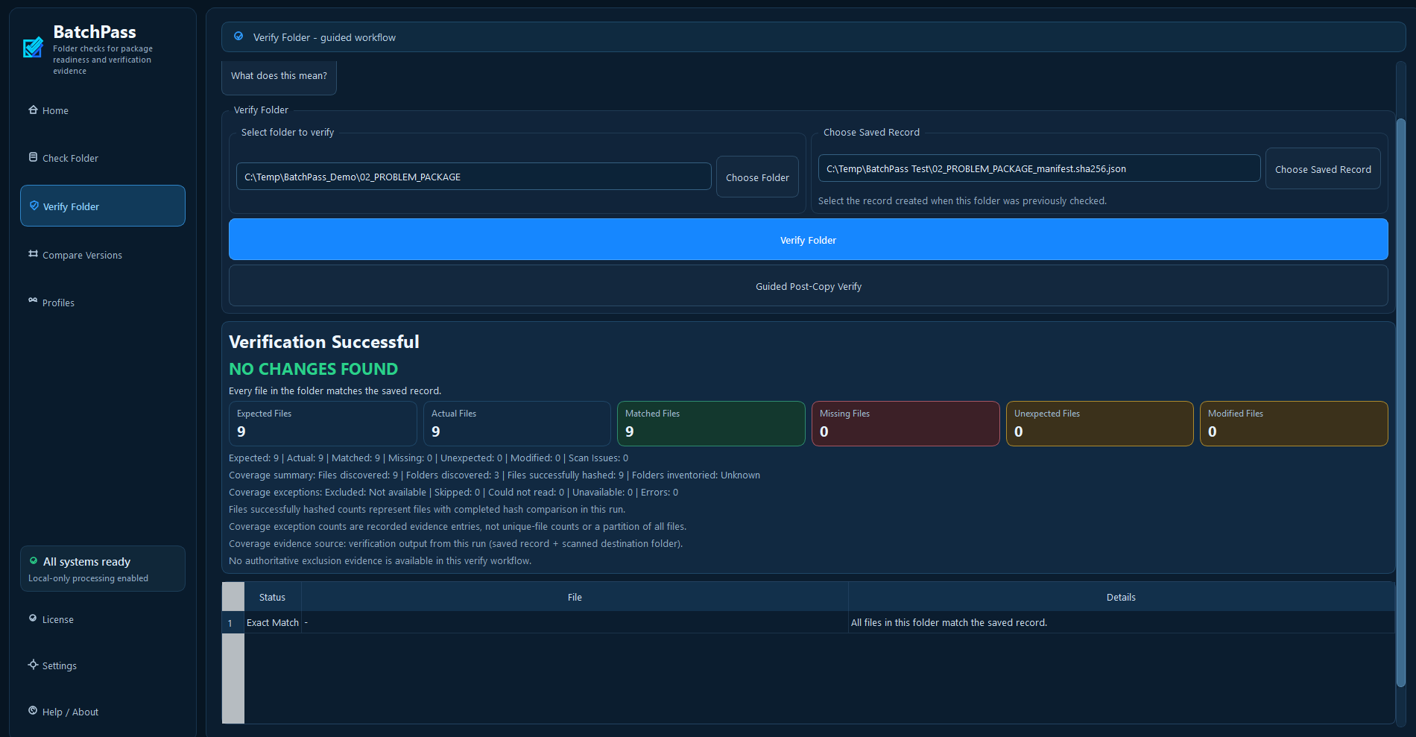
Verification reports Matched, Missing, Unexpected, and Modified files. Results remain on the Verify page after completion; read the coverage caveat and exception information there.

How to verify
1 | Create a Saved Record first  Run Check Folder on the original delivery and use Save Record.
2 | Open Verify Folder  Select Verify Folder from the left navigation.
3 | Select the current folder  Choose the folder you want to verify.
4 | Choose the Saved Record  Select the record created when the folder was previously checked.
5 | Run Verify Folder  TavrendoPass compares file paths and SHA-256 fingerprints.
6 | Review and save the result  Read the persistent summary, file categories, and coverage. Use Save Verification Report when you need a copy of the verification result.

What the verification categories mean
Matched: A recorded path is present and its SHA-256 fingerprint matches.
Missing: A recorded file was not found in the current scan. Review coverage before treating this as proof of absence.
Unexpected: A file is present now that was not recorded previously.
Modified: The file path may still exist, but its contents no longer match the saved fingerprint.
If coverage is incomplete, a missing result does not always prove physical absence: part of the folder may have been unreadable or unavailable. Investigate coverage exceptions before drawing that conclusion.

Verify after copying or delivery
1. Check the source folder with the appropriate Profile and review findings and coverage. Correct any issues outside TavrendoPass, then rerun.
2. Create and retain a Saved Record of the source folder before transfer.
3. Copy or deliver the files using your usual tools.
4. Choose Verify After Copy/Delivery on Home. Select the source Saved Record and the destination folder.
5. Run verification and review Matched, Missing, Unexpected, Modified, and coverage exceptions.
6. Save the available verification CSV or readable report for your records.
TavrendoPass verifies the selected destination. It does not perform the copy, repair differences, or establish authorship or legal authenticity. Review the persistent result and save the verification report if needed.

11. Compare Versions and Live Folders
The Compare Versions page supports two separate workflows: comparing Earlier and Newer Saved Records, or comparing Folder A and Folder B directly.
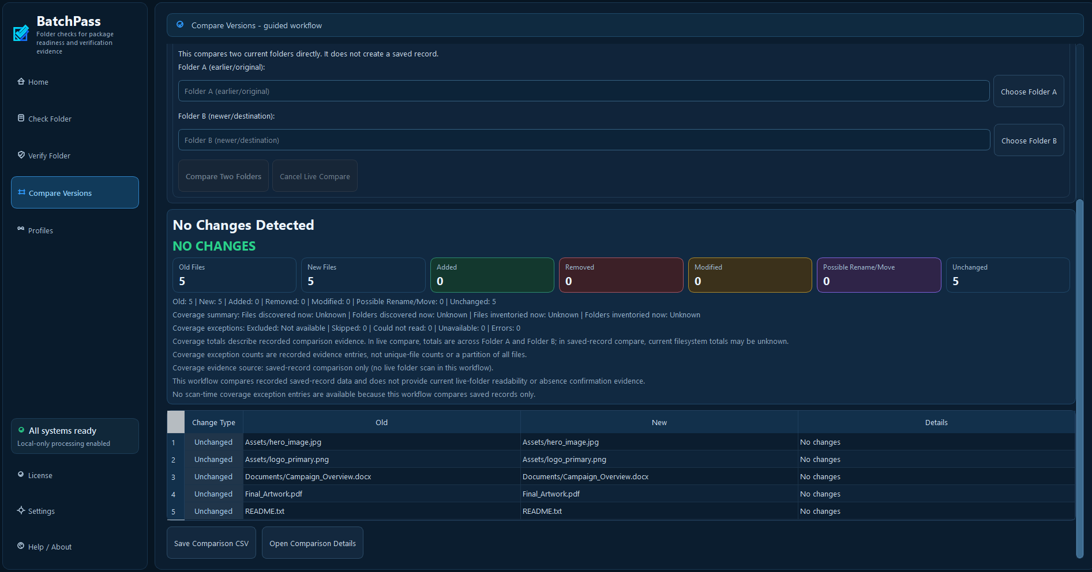
Saved-version comparison reads stored records. Live-folder comparison scans current contents. Choose the workflow that answers your question.

Compare Saved Versions
1 | Save the earlier version  Check the earlier folder and save a record.
2 | Save the newer version  Check the later folder and save a second record.
3 | Open Compare Versions  Select Compare Versions from the left navigation.
4 | Choose earlier and newer records  Make sure the older record is in the Earlier field and the newer record is in the Newer field.
5 | Run and review the comparison  Run the comparison, then read the persistent summary and table. Use Open Comparison Details only when you want the additional file-change details.

Compare Two Live Folders
Use this workflow to compare two current folders without creating Saved Records first. A Profile is not required.
1. Choose Compare Two Live Folders from Home, or scroll to the live-folder section on Compare Versions.
2. Select Choose Folder A and pick the baseline folder, such as the original source.
3. Select Choose Folder B and pick the folder to compare, such as the destination copy. Confirm both displayed paths.
4. Select Compare Two Folders. Review the progress and wait for completion.
5. Read the persistent comparison summary, coverage information, and change table. The workflow does not copy or modify either folder.
6. Use Save Comparison CSV to retain the file-change rows. Open Comparison Details is optional.
Added means present in Folder B but not Folder A. Removed means present in Folder A but not Folder B. Reverse A and B only if you intend to reverse that interpretation.
Live comparison does not create a Saved Record. Create one separately if you need a baseline for future Verify Folder use.

Comparison Results and CSV

Change types apply to both comparison modes
Added: Present in the Newer Saved Record or Folder B, but not in the Earlier Saved Record or Folder A.
Removed: Present in the Earlier Saved Record or Folder A, but not in the Newer Saved Record or Folder B. With incomplete live coverage, investigate exceptions before concluding that the file is absent.
Modified: A corresponding path exists on both sides, but its recorded content fingerprint differs.
Unchanged: A corresponding path has matching recorded content fingerprints. Saved-version comparison describes the records, not the files currently on disk.
Possible Rename/Move: Matching SHA-256 and size evidence suggests a rename or move. The match must be unambiguous across the compared inventories. Repeated identical content can prevent a candidate from being shown.
Compare results remain on the main page. You do not need to dismiss automatic completion pop-ups to reach the table or export action. Open Comparison Details is an optional dialog for more file-change information.
A Possible Rename/Move candidate is additional evidence. Its underlying Added and Removed rows remain in the comparison and CSV. Do not add candidate counts to file totals or treat the candidate as a confirmed rename.
The main comparison table is a simplified view with Change Type, Old, New, and Details. Save Comparison CSV includes old and new paths, sizes, and SHA-256 fingerprints for more detailed documentation.
The fixed CSV columns are change_type, old_path, new_path, old_size, new_size, old_sha256, and new_sha256. Empty fields are expected where a side does not exist, such as the old fields for an Added file.
Excel uses row 1 for the CSV column headers, so the first data row is Excel row 2. On-screen row numbers are display positions, not permanent file identifiers. Use change type and file paths to match rows.
If a hash or filename appears truncated in Excel, widen the columns or use AutoFit. A narrow cell does not mean the exported fingerprint is incomplete.
Coverage warnings and evidence remain on the Compare page and are not CSV columns. Open Comparison Details contains file-change details, not a full coverage-ledger report. Review the page’s coverage caveats before sharing the CSV.

12. Common Workflows

Website client handoff
Use or customize a Website Client Handoff Profile. Check required files/folders and unwanted temporary artifacts. Save a Record when ready.

Photo delivery
Use or customize a Photo Delivery Profile. Check folder contents and delivery structure, then save proof for the job.

Numbered document set
Use a Numbered Document Set Profile when sequence gaps matter. Review any missing-number warnings or failures.

Archive verification
Check and save a Record before archiving. Later, use Verify Folder to confirm the archive still matches the saved state.

Repeated client delivery
Create a client-specific Profile once. Use Repeat Recent Check to restore the Folder and Profile pair, then run a fresh check.

Versioned delivery
Save a Record for each significant version, then use Compare Versions to document what changed.
Compare a copied destination
Choose Compare Two Live Folders with the original as Folder A and the copy as Folder B. This compares the two current inventories; Verify Folder instead uses a retained Saved Record as its baseline.

13. Troubleshooting
My folder failed even though it looks correct
Open the Issues area. A failure means the selected Profile expected something different. Check required files, folder names, extensions, sizes, duplicates, and sequence rules.
A Starter Template gives too many failures
Templates are starting points. Customize the template so its requirements match your actual delivery.
I selected the wrong Profile
Return to Check Folder and change the Profile, then run the check again.
I changed files after getting PASS
Run the check again. A previous PASS describes the folder at the time it was checked.
Verify Folder shows Modified
The saved fingerprint and current file contents differ. Confirm whether the change was intentional.
Verify Folder shows Unexpected
A file now exists that was not present in the Saved Record.
Compare Versions looks reversed
Confirm the older Saved Record is selected as Earlier and the newer record as Newer.
I cannot find an old custom Profile
Custom Profiles are separate from bundled sample Profiles. Use the Profiles screen or locate the saved Profile file you created.
I cannot select the second live folder
Use the separate live-folder section on Compare Versions. Select Choose Folder A and Choose Folder B, then confirm both paths. The saved-record selectors above are for a different workflow.
The Home action or export button is out of view
Maximize the window or scroll. At smaller window sizes, some panels and actions require vertical or horizontal scrolling.
The progress bar reached 100% but the result is not PASS
The run completed its work. Read the actual check, verification, or comparison result and the coverage warnings.
Coverage is unknown or incomplete
Review the reason entries. Resolve permissions, availability, or read problems as appropriate, then rerun. A saved-record comparison cannot supply a fresh live-folder scan.
Repeat Recent Check cannot restore a setup
Select an explicit replacement for a missing folder or Profile. Review the current choices and start a new check.
My CSV has an extra row and more fields than the screen
The first spreadsheet row is the header. Comparison CSV also contains sizes and SHA-256 fingerprints that are not shown in the simplified main table.

14. Frequently Asked Questions

Does TavrendoPass upload my files?
Folder checks, verification, and comparison run locally without requiring checked folder contents to be uploaded. Internet access is required for initial license activation. A successfully activated Full License can continue working offline.
Can TavrendoPass delete or change my source files during an audit?
Ordinary checks do not alter source files. Report actions write the output you choose. TavrendoPass does not silently delete, rename, move, or overwrite source files.
Does PASS mean the documents themselves are correct?
No. PASS means the configured checks were satisfied based on the available evidence. Review coverage and recorded exceptions even with PASS. TavrendoPass does not certify legal, engineering, professional, design, or content correctness.
Do I need a Profile every time?
Check Folder requires a Profile. Verify Folder uses a Saved Record. Live-folder comparison requires two folder selections and does not require a Profile.
Should I use a Starter Template forever?
Not necessarily. Templates are objective starting points. Review and customize them for your real delivery requirements.
What is the difference between a Profile and a Saved Record?
A Profile defines what should be checked. A Saved Record documents what was actually present in a checked folder at a point in time.
Why save a Record if I already have a CSV report?
A CSV documents results for spreadsheet review. A Saved Record supplies the stored baseline required by Verify Folder and Compare Saved Versions. Keep it separately for future use.
Does Verify Folder prove a file is authentic?
It confirms whether the current file fingerprints match the fingerprints stored in the selected Saved Record. It does not establish legal authenticity or authorship.
Can I compare any two folders directly?
Yes. Use Compare Two Live Folders on Home or the separate live-folder section of Compare Versions. Choose Folder A and Folder B; existing Saved Records are not required.
What if I make a mistake in a Profile?
Edit or customize the Profile and run the check again. Profile quality determines how useful the check will be.
Does No Changes mean every file was readable?
Read the coverage information as well. Incomplete evidence limits what the result can establish; saved-record comparison only compares stored data.
Does Possible Rename/Move confirm a rename?
No. It is a conservative candidate based on matching content and size. Added and Removed rows remain.
Does Repeat Recent Check run automatically?
No. It restores setup references. Start a fresh run after reviewing the current Folder and Profile.
Can TavrendoPass inspect ZIP contents or read PDF text?
No. It checks and fingerprints the ZIP or PDF as a whole file. It does not audit files inside an archive or interpret a document’s contents.
Why do I see only Save Comparison CSV on Compare?
Exports belong to their workflow. Compare saves file-change CSV rows; Check has its own report actions. A verification report is a separate output, and comparison coverage notes remain in the application.

15. Safety, Privacy, and What TavrendoPass Does Not Do
TavrendoPass is intentionally conservative. It checks and reports; it does not silently repair your delivery.
Design principle | What it means
Read-only audits | Source files are not changed by ordinary checks. File contents are read locally as needed.
No silent file changes | TavrendoPass does not silently delete, rename, move, or overwrite source files. Report actions write the output you choose.
Local-first | Selected file contents are processed locally. License activation and purchase services are separate from folder checking.
Rule-based checking | Results depend on the Profile and file/folder  properties that TavrendoPass is configured to evaluate.
No professional certification | TavrendoPass does not certify legal, engineering, professional, or content correctness.
Keep private files and reports secure. Reports may contain filenames, paths, sizes, and fingerprints. Do not send customer files to support unless a safe example is specifically needed.
TavrendoPass checks files as files; it does not inspect individual items inside ZIP archives or interpret PDF text, pages, or document meaning. A ZIP or PDF can be fingerprinted as a whole file to detect a content change. Results are not backup, continuous monitoring, malware scanning, content validation, or an atomic snapshot of files changing during a run.

16. Quick Reference
Need | Use
Check a folder before sending | Check Folder
Reuse requirements | Profiles
Start with ready-made rules | Starter Templates
Confirm nothing changed | Verify Folder
Compare two saved states | Compare Versions
Readable verification results | Save Verification Report
Spreadsheet-friendly results | CSV Report
Future verification/comparison | Saved Record
Compare two current folders | Compare Two Live Folders
Verify a copied destination | Verify After Copy/Delivery
Restore a previous setup | Repeat Recent Check
Save verification results | Save Verification CSV / Save Verification Report
Save comparison change rows | Save Comparison CSV

First-time user checklist
• Choose a real delivery type you perform regularly.
• Start with a Starter Template or create one simple Profile.
• Run the Profile against a known-good folder.
• Run it against a deliberately broken folder.
• Adjust rules until the results match your expectations.
• Use that Profile for real deliveries.
Save the needed report and Saved Record, and read coverage caveats before relying on the result.

17. Getting Help
If something in TavrendoPass is unclear, start with the section of this guide that matches what you are trying to
do. For additional help, visit the TavrendoPass Support page or contact the support address provided with your
purchase.
Support: https://www.getbatchpass.com/support
When asking for help, include your TavrendoPass version, workflow, relevant Profile or record, and the exact result or error message.
For Compare, state whether you used Saved Records or live folders. Include coverage warnings and the steps that reproduce the problem.
Do not send private customer files unless support specifically asks for a safe example.
TavrendoPass v1.1 User Guide

